**PRAYER & PRAISE**

* Pray for the team as they head down for hurricane relief.
* Pray for our country and the election this week.
* Pray for the persecuted church.

**LAST WEEK**

|  |  |
| --- | --- |
| General Fund Offering | $8,019.00 |
| Missionary Offering | $495.00 |
| Worship Service Attendance | 129 |
| Sunday School Attendance | 78 |

**ELDERS**

Todd Baisley, Pastor

todd@rockvillemennonite.com, (610) 858-0817

Jaidan Piper, Assistant Pastor

jaidan@rockvillemennonite.com, (484) 655-2270

Doug Moser, Elder

**SERMON NOTES**

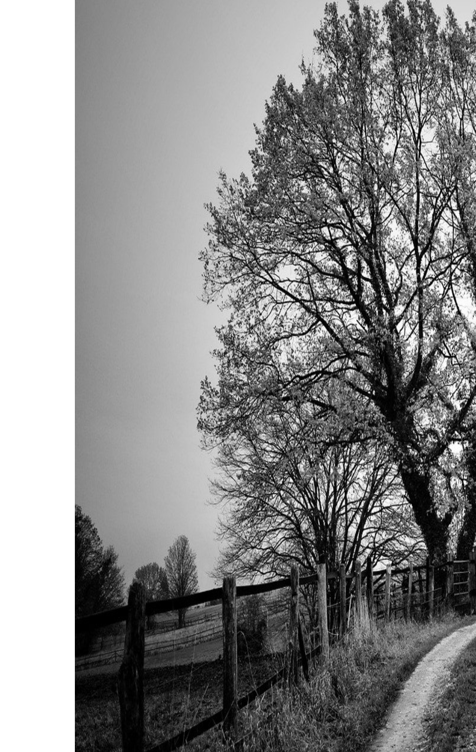

WELCOME

We are glad

you are

worshipping

with us!



610-273-9577

office@rockvillemennonite.com

www.rockvillemennonite.com

elcome To

Welcome to



November 3, 2024

**9:30 a.m. Sunday School**

**10:30 a.m. Worship Service**

**Prelude**

**Announcements**

**Call to Worship –** Gene Smucker

**Worship in Singing**  - Jay Smoker

**Prayer**

**Worship in Hearing the Word**

“A Psalm for the Persecuted Church”

Todd Baisley

**Closing Song**

Greeters: Marv & Cheryl Stoltzfus

Ushers: Roger Blank, Jordan Zimmerman

***Today’s Special Offering is for:*** *U Turn for Christ PA,*

*Men’s ministry*

***Next week’s Special Offering is for:*** *Steeple to People*

**NEXT WEEK**

Call to Worship ---- Doug Moser

Sermon------------- Todd Baisley

Greeters ------------ Rich & Carol Ann Burns

Ushers -------------- Jeremy Zimmerman

**ANNOUNCEMENTS**

There will be prayer meeting at 5:00 p.m. this evening at RMC.

The elders will be meeting Monday, November 4 at 7 p.m.

We will be having a Thanksgiving Eve Service November 27 at 7:00 p.m.

Church name suggestions can be submitted to the box in the foyer or you can email them to office@rockvillemennonite.com for four weeks. Name suggestion slips are in the foyer.

**UPCOMING EVENTS**

**November 3 –** International Day of Prayer for the

Persecuted Church

**November 4 –** Jr Youth Event

**November 5 –** Bible Study at Pipers/Catmans

**November 6 -** Young Adult Bible Study

**November 10 –** Young Adult Fun & Fellowship

**November 12 –** Men’s Bible Study

**November 13 –** Sr Youth Bible Study

**November 19 –** Church Council Meeting

**November 21 –** Ladies Prayer Meeting

**November 27 –** Thanksgiving Eve Service

**December 6** – Sr Youth Christmas Banquet

**December 8** – Holly Trail

**December 14, 15** – A Christmas Festival of Lights 6-8 p.m.

**MONTHLY MISSIONARY**

Leon & Naomi Zimmerman

775 Bellevue Ave

Gap PA 17527-9609

Serving with Eastern Mennonite Missions

Email: lznz4@yahoo.com

**BIRTHDAYS & ANNIVERSARIES**

|  |  |
| --- | --- |
| Jordan Smucker | 11/3 |
| Michael Stoltzfus | 11/4 |
| Maddie Mellinger | 11/5 |
| Jaidan Piper | 11/5 |
| Jordan Zimmerman | 11/9 |
|  |  |
| Dale & Mary Weiler | 11/8/1980 |